LYME BAY MEDICAL PRACTICE
ZOOM PATIENT PARTCIPATION GROUP MEETING
Date: Tuesday 30th June 2020
Time: 3.00 – 4.15pm
In attendance: Alison Robinson – Patient Service Manager
Sarah Hill – Practice Manager
Joanna Churchill – Admin
Jo Ellis – Guest Speaker

Patient Representatives: David Edwards – Joint Chair
David Hardman -Joint Chair
Shirley Williams
Caroline Aldridge
Pauline Frost
Caroline Powley
Victoria Stocqueler

- Welcome & introductions
Sarah Hill welcomed and thanked everyone for attending

- Matters arising from last meeting: Minutes checked, and all outstanding items completed with Sarah sending a staff organisation chart to all members
- Practice feedback
- As a practice we stopped face to face consultations unless needed and converted to telephone consultation and video consultation and more recently e-Consults which has been received very well by staff and patients
- We, along with the community nurses & frailty team have regular joint video meetings with nursing homes to offer help & support for any concerns they may have.
- Staff trained in infection control and maintaining social distancing
- Regular updates on Facebook, website and posters within the surgery.
- Practice nurses visited shielded patients

Day | GP Available
Monday | Dr Watson, Dr Davies & Dr Wilson
Tuesday | Dr Wilson, Dr Hodges & Dr Smith (KH)
Wednesday | Dr Wilson, Dr Davies & Dr Taylor
Thursday | Dr Davies & Dr Smith
Friday | Dr Watson & Dr Wilson

- Community Services Update
- Community Nurses: Carried on and offered a normal service with support from the nurses from Lyme Bay, new HCA has started and 2 more to join shortly
- Physio: Haven’t been running for face to face but due to start on Wednesday
- Podiatry: Currently not working and due to re-start in August.
- Guest Speaker – Jo Ellis lead social prescriber health
Jo Ellis introduced herself as lead social prescriber and explained what she and her team have brought and will continue to bring to the practice in the future to support health and wellbeing of our patients Referrals can be generated from the GP, nurses, admin & health campions but patients can also self-refer. The types of problems that can benefit from the support are pain, grief, depression, loneliness, long term health problems, mobility and many more.
Jo also made an excellent presentation.

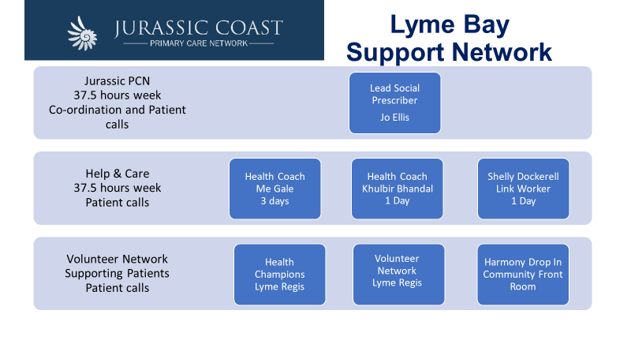

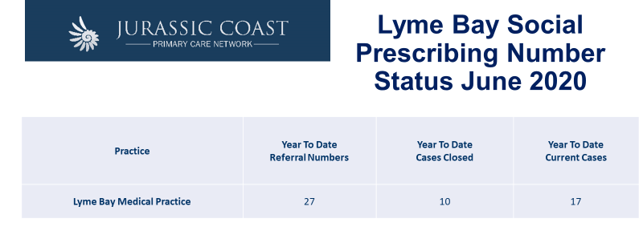

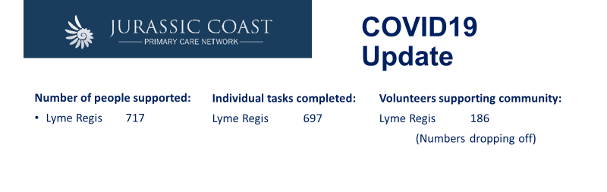

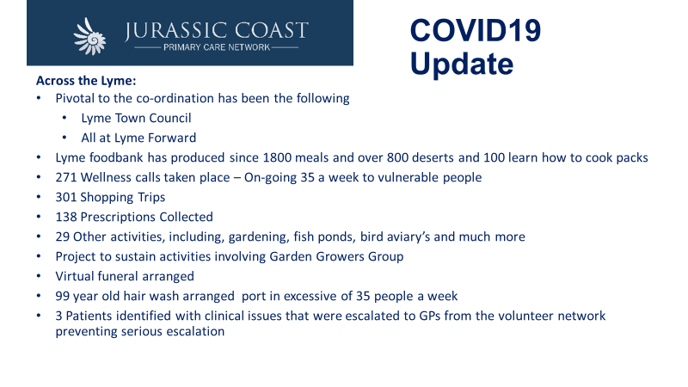David H - Uplyme Parish Council have set up a support network and Help at Hand continues its voluntary support with a new generation of 40-50-year olds and teenagers from Woodroffe school joining the team as many of The Help at Hand group are over 70 and are having to self-isolate.

Patient Feedback
- Feedback has mainly been positive and many patients adapting very well to new services we have had to introduce. All PPG members had only heard good and positive comments

- Practice Plan.
- Patients are able to now have face to face appointments with the GP’s, but it would initially be a telephone consultation
- Screens up in reception and door remaining open on a trial basis to see if we can control the foot flow through the door
- Social distancing signs & informative signs
- Face covering by all staff in patient facing role
- Hand gel available
- Thorough cleaning
- Continue to promote video/tele consultations and e-Consult

- PPG Support
PPG group to support as they have always done and further PPG support to be discussed once the practice starts to go back to some form of normal. As a practice we are certainly keen for help once our flu campaign begins

- AOB
- A thank you from the PPG members for the work we have done
- Caroline Powley has spent lockdown completing an 8-week NHS diabetic program and will work alongside Jo Ellis promoting and helping with diabetic patients

- Date of Next Meeting - Tuesday 1st September 2020

